Experiment A1: Electromyography
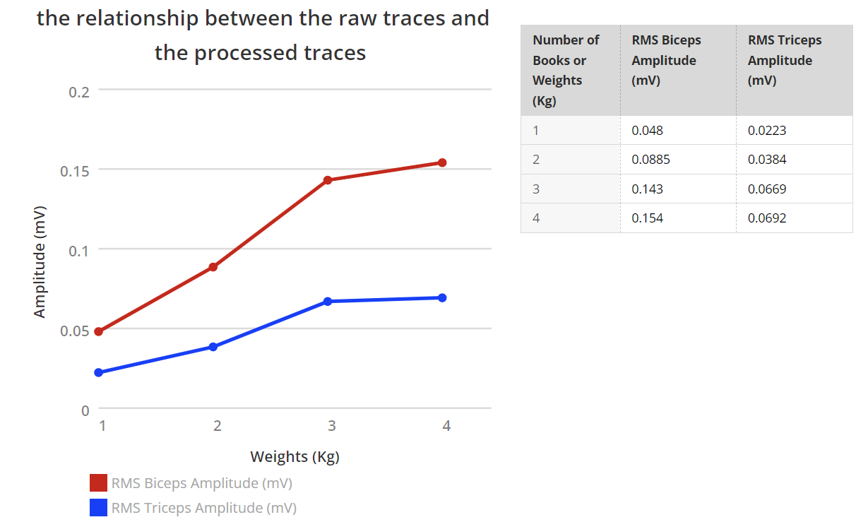
Experiment 1B: Muscle Fatigue
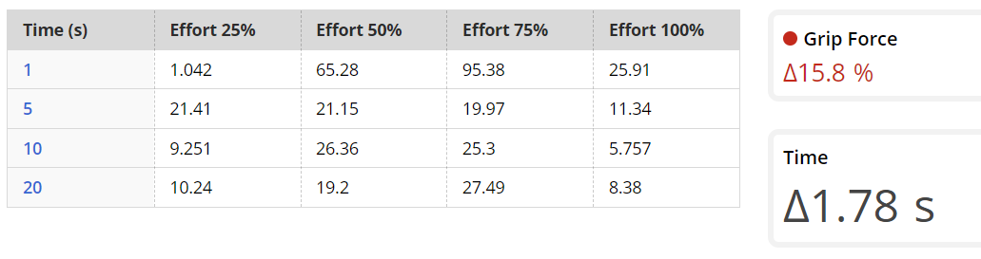
Part 1B: Force with Encouragement
